**Project Design Phase-I**

**Architecture Diagram**

|  |  |
| --- | --- |
| Date | 19 October 2022 |
| Team ID | PNT2022TMID04164 |
| Project Name | Project - AI based discourse for Banking Industry |
| Maximum Marks | 2 Marks |

**Architecture Diagram :**

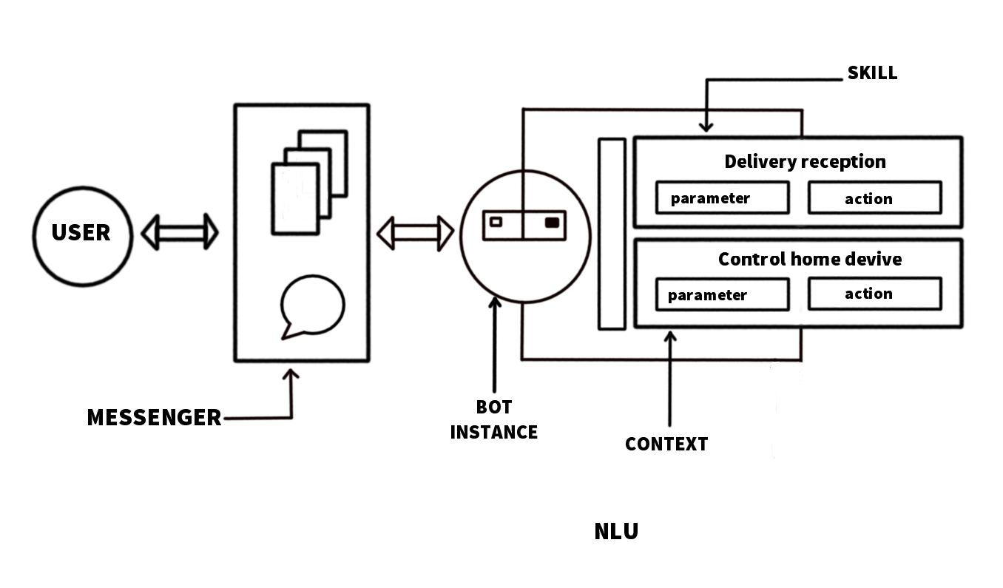

**Components:**

1. User
2. Messenger
3. Bot Instance
4. Context
5. Parameters
6. Actions
7. Delivery reception
8. Control home device
9. Natural language understanding

**1.User:**

Chatbots in banking industries can help customers with issues that can be non-complex but urgent. These issues include unlocking or locking cards, resetting, checking bank statements, and completing fund transfers. AI chatbot allows customers to complete the entire process without waiting on the phone.

**2. Messenger:**

A chatbot is a piece of automated messaging software that uses artificial intelligence to converse with people. Facebook Messenger bots live within Facebook Messenger, and can converse with some of the 1.3 billion people who use Facebook Messenger every month. Chatbots are like virtual assistants. These messengers are found in websites and in apps.

**3. Bot Instance:**

A banking bot is built using artificial algorithms that analyzes user's queries and to understand user's message. The system is designed for banks use where users can ask any bank related questions like loan, account, policy etc. This application is developed for android devices.

**4.Context:**

Context allows the user to have an informal conversation with the AI chatbot using pronouns. The intent in each message is identified and carried forward across multiple messages. Contextual feature helps shape the speech according to the need and environment.

**5. Parameters:**

* Easy customization
* Quick chatbot training
* Easy omni-channel deployment
* Integration with 3rd-party apps
* Interactive flow builder
* Multilingual capabilities
* Easy live chat

**6.Actions:**

* Transfer Money
* Get Account Balance
* Send Timely Alerts & Notifications
* Track Transactional History
* Tackle Suspicious Activities
* Hassle-free Application for Other Services
* Customer Support with just One Tap
* Easy & Uncomplicated Lead Generation
* Personal Banking Assistance
* Make Secure Payments

**7. Delivery reception:**

A document that proves that a person has received a message.

**8. Control home device:**

A home automation system will monitor and/or control home attributes such as lighting, climate, entertainment systems, and appliances. It may also include home security such as access control and alarm systems.

**9. Natural language understanding:**

Natural language understanding is a branch of artificial intelligence that uses computer software to understand input in the form of sentences using text or speech. NLU enables human-computer interaction.